Patent Search:

KEYWORDS: steerable, bendable, handle, surgical instrument, middle ear surgery, adjustable

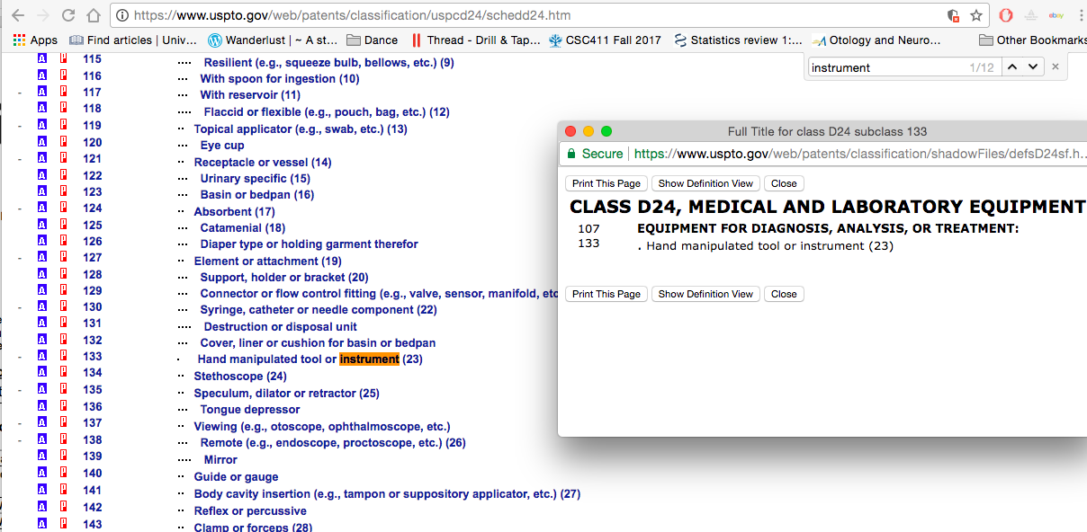

Classes:

|  |  |
| --- | --- |
| **CLASS D24, MEDICAL AND LABORATORY EQUIPMENT** | |
| 107 | **EQUIPMENT FOR DIAGNOSIS, ANALYSIS, OR TREATMENT:** |

|  |  |
| --- | --- |
| 133 | . Hand manipulated tool or instrument (23) |

Click on the “p” button beside the class

<http://patft.uspto.gov/netacgi/nph-Parser?Sect1=PTO2&p=1&u=%2Fnetahtml%2Fsearch-bool.html&r=0&f=S&l=50&TERM1=D24%2F133&FIELD1=ORCL&d=pall>

Tools, systems and methods for inserting an electrode array portion of a lead into a bodily orifice

Patent number: US008753353B2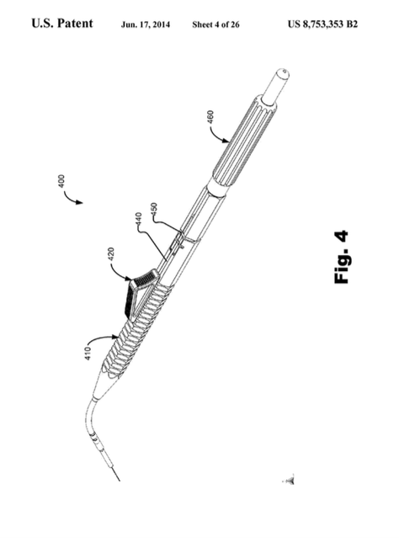

Adjustable Laser Probe for Use in Vitreoretinal Surgery

US20050154379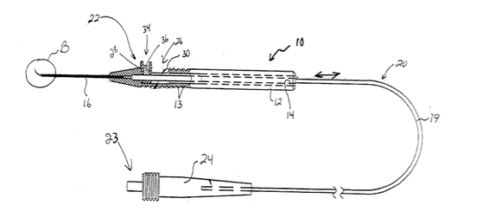

Oscillating, Steerable, Surgical Burring Tool and Method of Using the Same

Patent number: US20040147934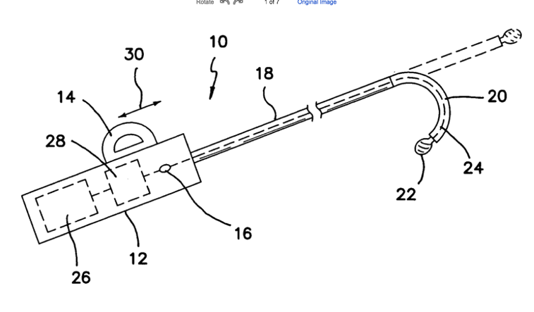

Steerable catheter

US6146355A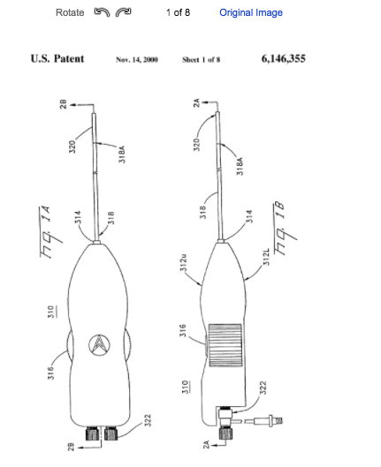

**Steerable Laser Probes:**

keyword: steerable laser probe

Salient Med Endoprobe

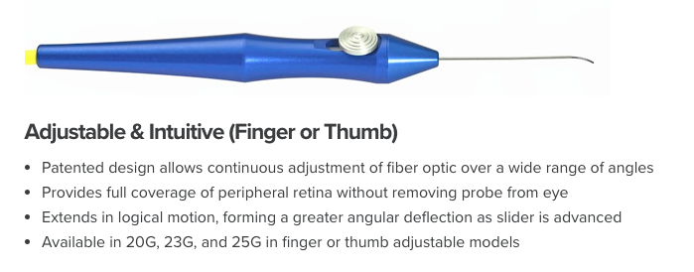 <http://salientmed.com/solution/endoprobe-handpieces/>

Healing Surgical Steerable Laser Probe

<https://healingsurgical.com.au/product/steerable-laser-probe#productDetailTab2>



Healing Surgical Revolver Laser Probe

* Reusable handle
* Laser connector
* Disposable fibre
* Curved, steerable tip

<https://healingsurgical.com.au/product/revolver-laser-probe>



I-Flex

* Steering range 0-90o in all directions

<https://www.bitegroup.nl/category/maneuverable-devices/i-flex/>

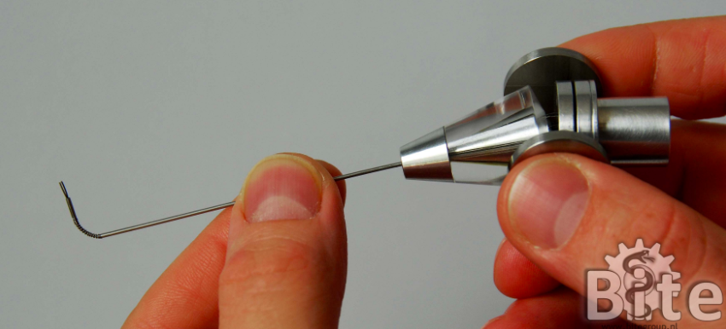

Steerable Laser Fibres from Company: Katalyst Surgical

US8840607B2 

* Preformed curvature wire

US20130071507A1 

* shape memory sleeve
* more similar patents from Katalyst: US20130096541A1, US20130071507A1, US20130085326A1

Steerable Tube:

US20110004157A1 

* Different handle – this one would not allow pen grip

Handle for an Endoscopic Surgical Instrument

Patent #: US0D0803396

Only claim: “an ornamental design for an endoscopic surgery instrument, as shown”

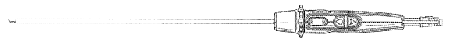

Catheter Actuation Handle

US0D0806244

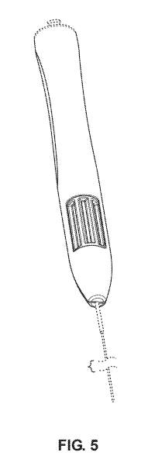

Medtronic Fusion ENT Navigation System:

<http://assets.medtronic.com/ent/flipbook-us/#p=44>

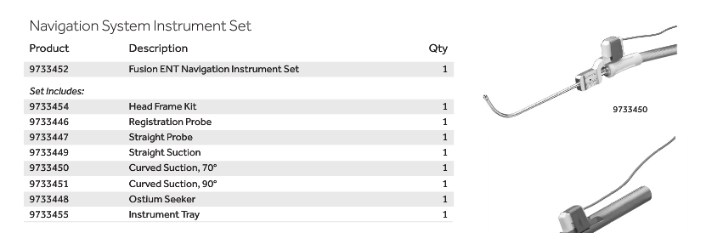

I think this has pre-curved suction

<http://www.medtronic.com/us-en/healthcare-professionals/products/ear-nose-throat/image-guided-surgery/fusion-ent-navigation-system/related-navigation-products.html#supplemental>

* Frontal Suctions, 45° and 90°
* Small Straight Suction
* Suction Curettes, 45° and 90°
* Elevator
* Standard Registration Probe and Head Frame Kit (not pictured)

<http://www.medtronic.com/us-en/healthcare-professionals/products/ear-nose-throat/image-guided-surgery/fusion-ent-navigation-system/related-navigation-products.html>

Endoscopic methods and devices for transnasal procedures

US20090030274A1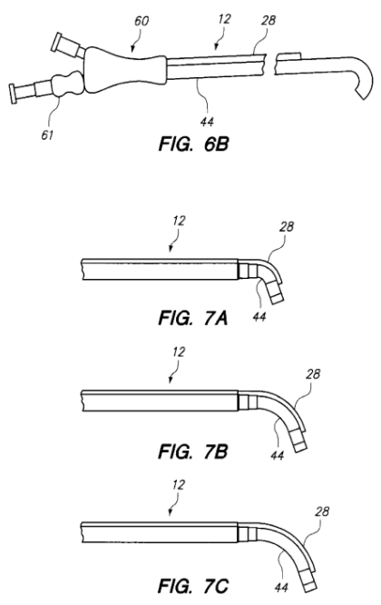

* Facilitate endoscope and guidewire insertion and positioning transnasally
* US8146400B2, US20070293727A1, US8146400B2,